POWER BI ASSIGNMENT 2
DAX AND DATA VISUALISATION
CALCULATED COLUMNS
● Create a Calculated Column for 'Category Type': Add a calculated column in the
Order Details table that combines the 'Category' and 'Sub-Category' columns into a
single 'Category Type' column.

TABLE TOOLS---NEW COLUMN---TYPE FORMULA IN FORMULA BAR—ENTER
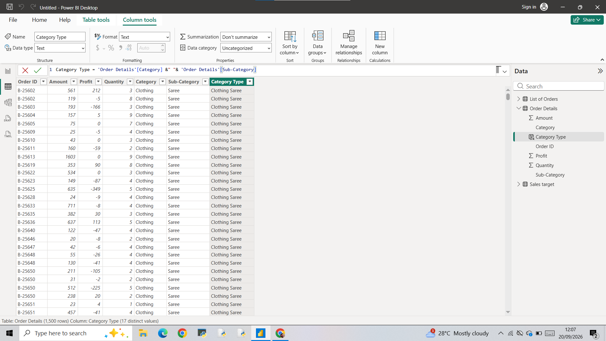

● Calculate Revenue per Order in Order Details Table: Create a calculated column in
the Order Details table to compute the revenue (Amount * Quantity) per order.
“Revenue per order=order details(amount)*order details (quantity)”
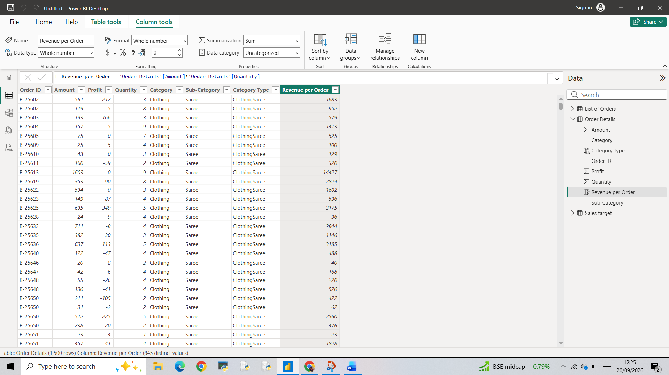

● Create a Calculated Column to Categorize Sales: Add a calculated column named ‘Sales Category’ in the Order Details table that categorizes each order as 'Above Average' or 'Below Average' based on the Amount value.
Here we can use IF FUNCTION
New column- apply formula as In the pic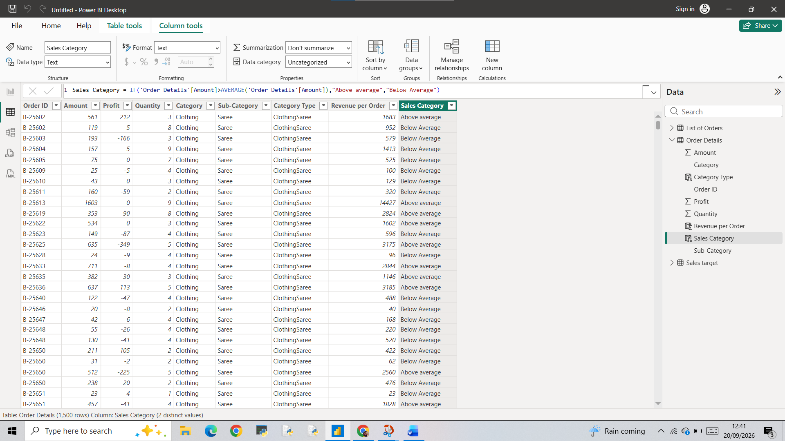
CALCULATED MEASURES
● Calculate Order Count: Define a measure to count the total number of orders in the
Order Details table.
Table tools—new measure—type formula
Write Dax formula—enter –measure will saved –go to report view –insert caed—drag measure into the card values

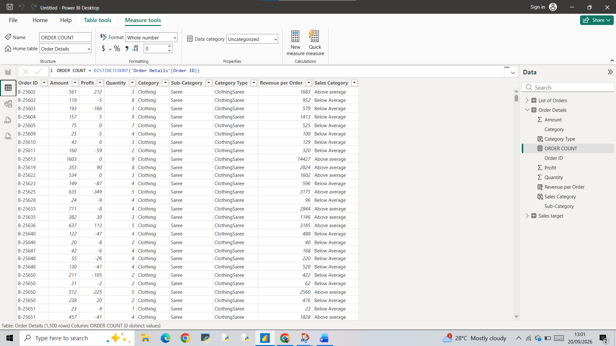
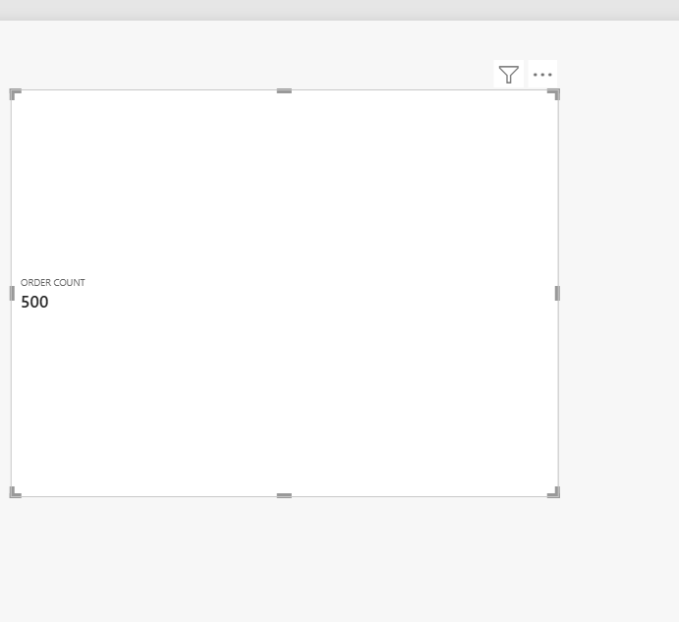

● Calculate Average Profit in Delhi: Create a measure to calculate the average profit for orders placed in Delhi.

For calculating average profit in Delhi ,First of all built relation ship with 2 tables through a column ,for that use power query editor change the list of orders ,first column as headers. Then through model view we can create relationship with both tables through order id column . then we can create measure
And using cards we can visualize it
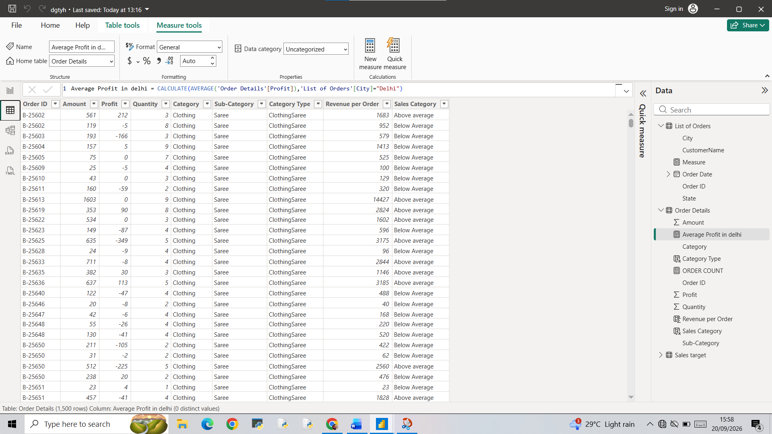

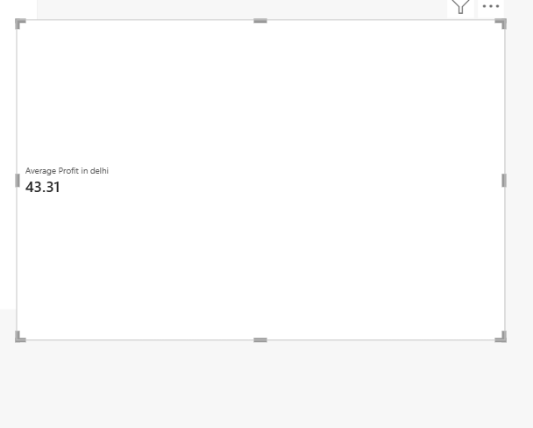

● Calculate Year-to-Date (YTD) Sales: Define a measure to calculate the total sales
amount accumulated from the earliest order date up to each order date.
New measure—type syntax as
YTD Sales=TotalYTD(SUM(‘Order Details’[amount]),’List of orders’[orderDate])
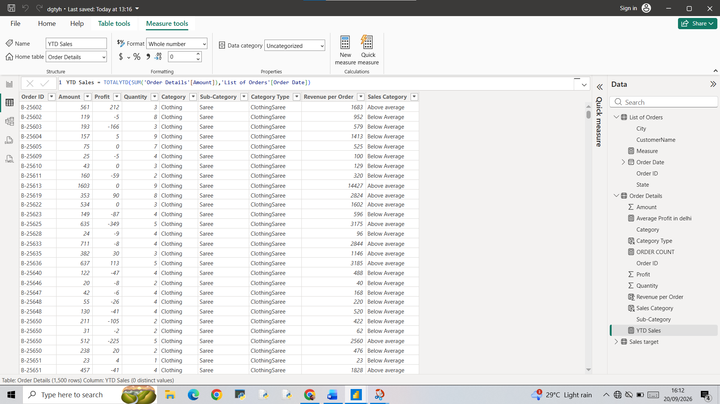
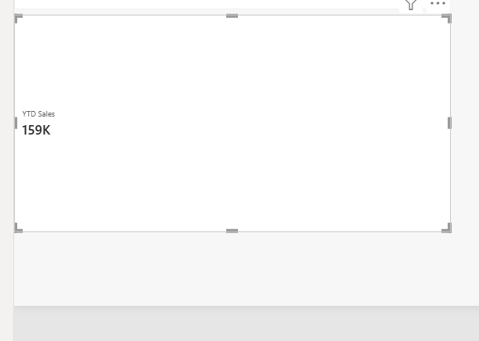

DATA VISUALISATION
Sales Target Achievement by Category: Compare actual sales with sales targets by
category using a clustered column chart.
Target Sales vs Actual Sales by category
First created two new measures
Actual sales and Target sales
Then build relation ship--
Using star schema new table created-- Active relationship build –then moving to visualisation part clustered chart prepared category as X Axis ang both Actual Sales and Target sales as Y Axis.
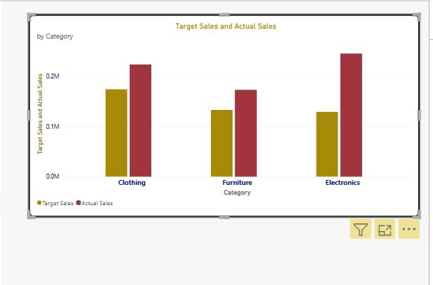
Max Profit Margin by Sub-Category: Analyse the maximum profit margin for each
sub-category of products using a donut chart.

New column created in order details as profit Margin Percentage.
After that new measure created to find Max of profit margin percentage.
Then create Donut Chart using subcategory as legend and Max Profit margin as values.

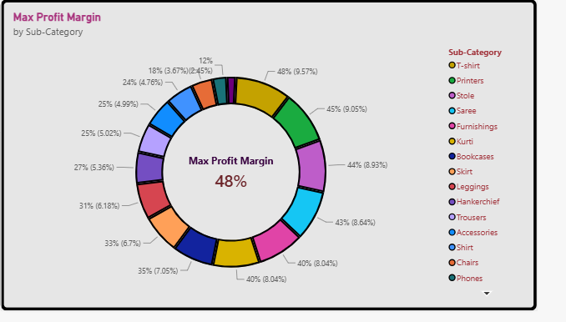
Monthly Sales Trend: Show the trend of monthly sales over time using a line chart.

Line chart preparation—taken Xaxis as order Date in list of orders
Then yaxis as both Actual sales and target sales
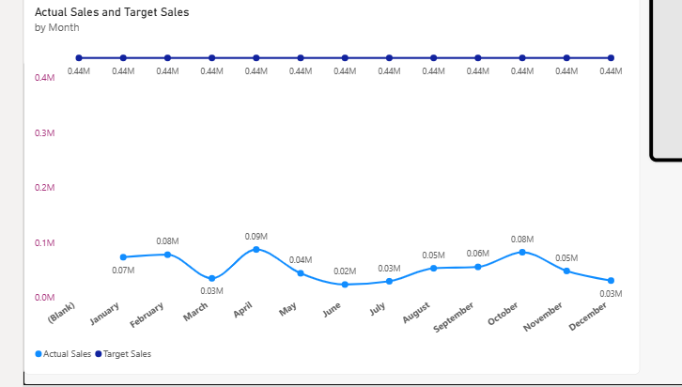

Comparison of Profit and Quantity by Sub-Category: Compare the relationship between
profit and quantity sold for different sub-categories using a scatter chart.
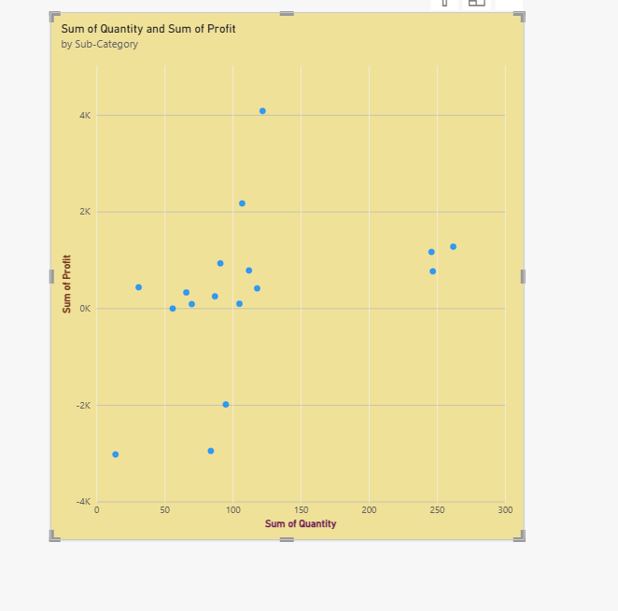
Comparison of Total Sales Amount and Target: Create cards to succinctly display the total
sales amount alongside the sales target for quick comparison and analysis. Also, create a
multi-row card to display the minimum target for each segment.
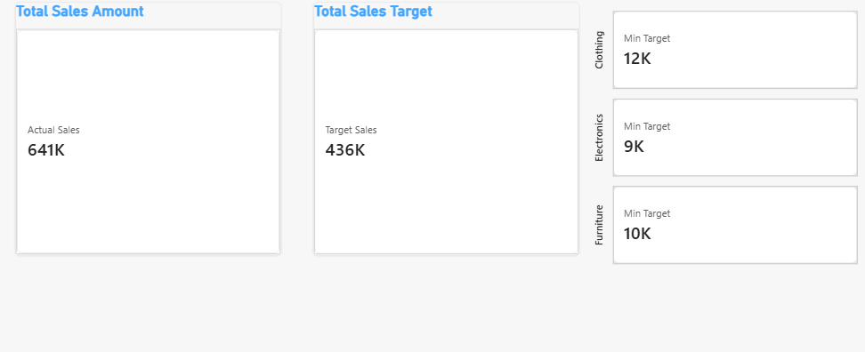

Sales Performance Matrix: Build a matrix view to analyse how actual sales compare to
sales targets across different categories and months

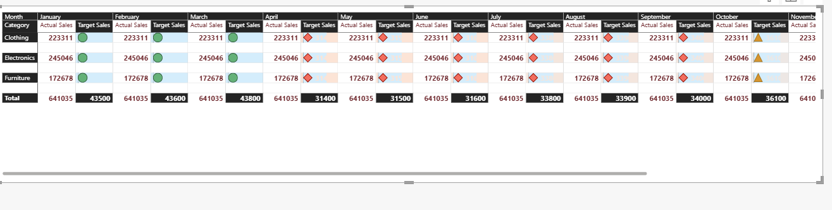
Geographic Sales Analysis: Visualize total sales on a map by city to identify regional sales Patterns

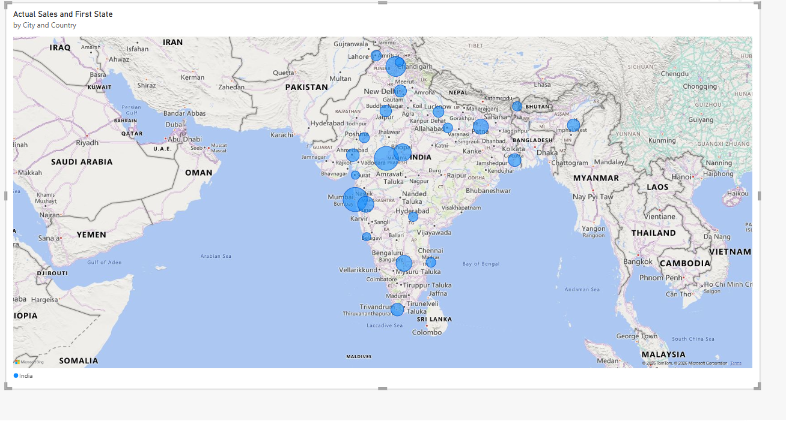

Sales Distribution by Sub-Category: Represent the sales distribution across different
sub-categories using a tree map.
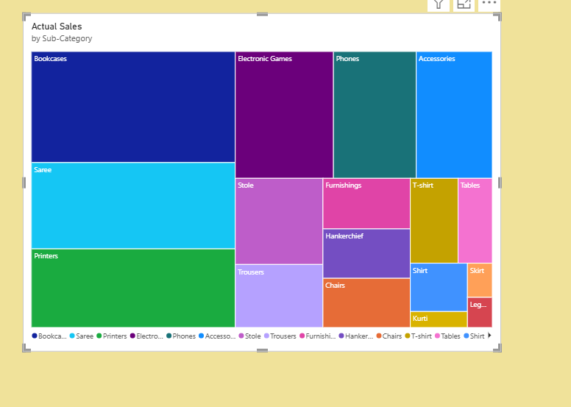
Order Count Analysis by State: Create a funnel chart to visualize the distribution of order
counts across different states.

